LAW FIRM BURG SIMPSON HOSTS TOYS FOR TOTS AND FOOD BANK OF THE ROCKIES DONATION DRIVES

Annual Toys for Tots and Food Bank of the Rockies Drives at Burg Simpson Feed Hundreds, and Provide Holiday Gifts for Children in Need

FOR IMMEDIATE RELEASE

ENGLEWOOD, CO— DECEMBER 2, 2022— The annual Food Bank of the Rockies drive at Burg Simpson Eldredge Hersh & Jardine provided almost 400 pounds of food, yielding over 330 meals, for families in our community this year. This annual food drive at the law firm’s main office in Englewood, CO has provided sustenance for thousands of families and individuals suffering from food scarcity for over a decade.

“We are really proud of this year’s food drive and hope next year will be even better. Our partnership with Food Bank of the Rockies speaks to the heart of our firm’s core values – it is an honor to help those in our community in their time of need”, said Stephen Burg, Shareholder and Personal Injury Practice Group Leader at Burg Simpson Eldredge Hersh & Jardine.

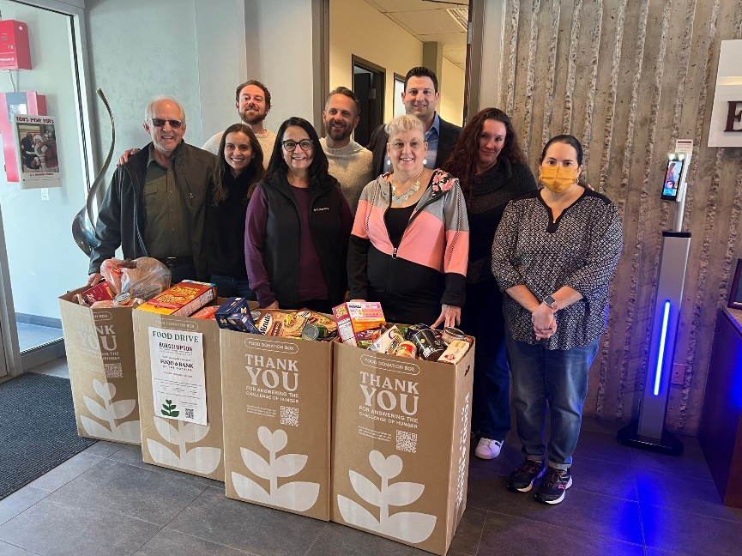

The lawyers and staff of Burg Simpson, their clients, and business peers bring their donations to the office every November, and deliver the donations to Food Bank of the Rockies in Denver, CO. Founded in 1978, Food Bank of the Rockies is the largest hunger-relief organization in the Rocky Mountain region of the U.S.
As a long-term partner of Toys for Tots, Burg Simpson is also an annual host of the holiday toy drive. Through December 19th, anyone may bring an unwrapped toy to the Burg Simpson office at 40 Inverness Dr. East, Englewood, CO 80112, where the Toys for Tots collection boxes reside in the main lobby.
Speaking about the annual toy drive, Stephen Burg said, “Toys for Tots is such a wonderful organization, and we are proud to help give less fortunate children the joy of the holiday season.”

If you or someone you know would like to be a recipient of the Toys for Tots holiday gift program, you may request a toy through their website at Marine Toys for Tots

###
ABOUT BURG SIMPSON
One of America’s foremost plaintiff trial firms, Burg Simpson Eldredge Hersh & Jardine has a reputation for fighting relentlessly and successfully for victims of negligence, malfeasance, malpractice, and abuse. Burg Simpson has secured more than $1 billion in verdicts, settlements, and judgments in practice areas spanning dangerous pharmaceutical drugs and devices, medical malpractice, personal injury, commercial litigation and whistleblowers, construction defects, workers’ compensation, and product liability, including more than 100 recoveries in excess of $1 million.

The firm was founded in 1976 by distinguished American trial lawyer Michael Burg, an inductee in the Trial Lawyer Hall of Fame and a recipient of the Clarence Darrow Award. Mr. Burg has been named to the 2016 RoundTable: America’s 50 Most Influential Trial Lawyers by The Trial Lawyer magazine; Barrister’s Best as “Best Civil Litigator”; and one of “America’s 50 Leading Trial Lawyers” by The U.S. Legal 500. Burg Simpson Eldredge Hersh & Jardine now has more than 70 lawyers, and offices in 7 states across the U.S.

Burg Simpson: Good Lawyers, Changing Lives®.

PRESS CONTACT:
Anne-Marie Kopek
303-792-5595
akopek@burgsimpson.com

